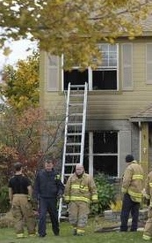

10/25/ 2013 Livonia Michigan. A fire ripped through a Bayberry Street home during the installation of a smart meter. According to the Detroit News the fire caused extensive damage. “DTE spokesman Scott Simons said service technicians were removing an old meter and installing an advanced meter when they saw signs of fire.”
CBS Detroit also reported on the fire stating the resident Kirk Lytwyn stated: “A representative from DTE was out here to change the meters and in the process of changing the meters, from what I understand, it blew on him, blew right in his face,” Lytwyn said. ”Apparently he was wearing the appropriate protective gear.”

Couple escapes house fire, dogs killed: smart meter blamed
October 14, 2014
by K. T. Weaver

Investigators now admit the smart meter “may have played a role in the fire.”
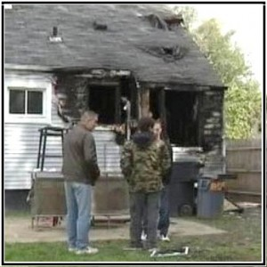

A couple barely escaped a house fire with their lives in Detroit, Michigan, early Sunday morning, October 5th, 2014. Sadly, their two dogs were killed in the blaze.
The homeowner blames the recently installed “smart” meter for the fire.
“It was DTE… why my dogs are dead, why my family is ruined, why I have no house, why I have nothing.”
Investigators from Detroit’s Fire Department say two circuit boxes were connected to the “smart” meter outside the house and one of them blew, but it wasn’t immediately clear to investigators whether the smart meter was the cause of the fire.
However, investigators confirmed on October 7th that the “smart” meter “may have played a role in the fire.”

